**Screenshot #1: VPC Creation**

**Description:**  
This screenshot shows the newly created VPC in the AWS console. These details confirm that the VPC was created according to the assignment requirements.

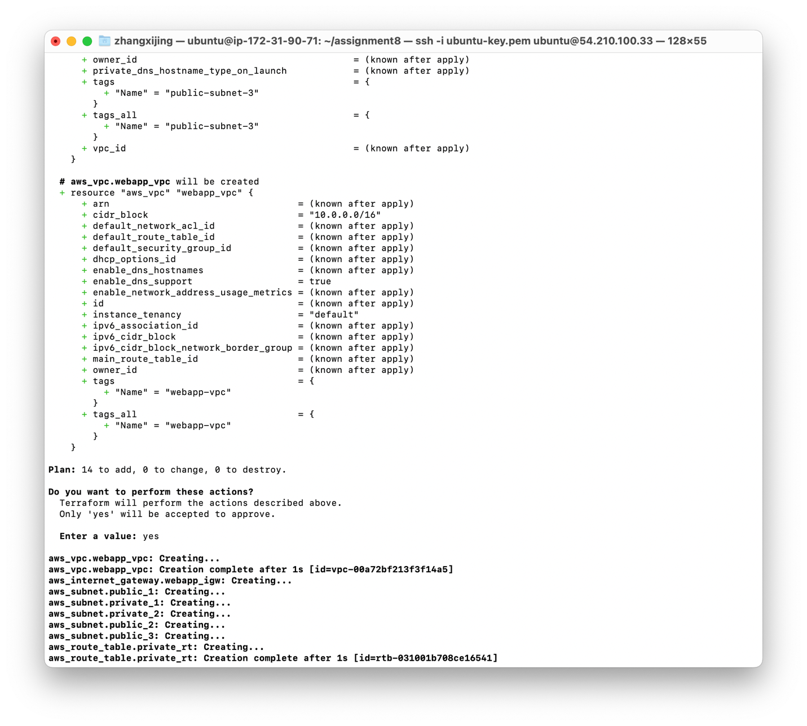

**Screenshot #2: Subnet Configurations**

**Description:**  
This screenshot shows:

* Each public subnet (10.0.1.0/24, 10.0.2.0/24, 10.0.3.0/24) in AZs us-east-1a, us-east-1b, us-east-1c
* Each private subnet (10.0.4.0/24, 10.0.5.0/24) in AZs us-east-1a, us-east-1b
* The Name tags, CIDR blocks, and Availability Zones as specified in the assignment

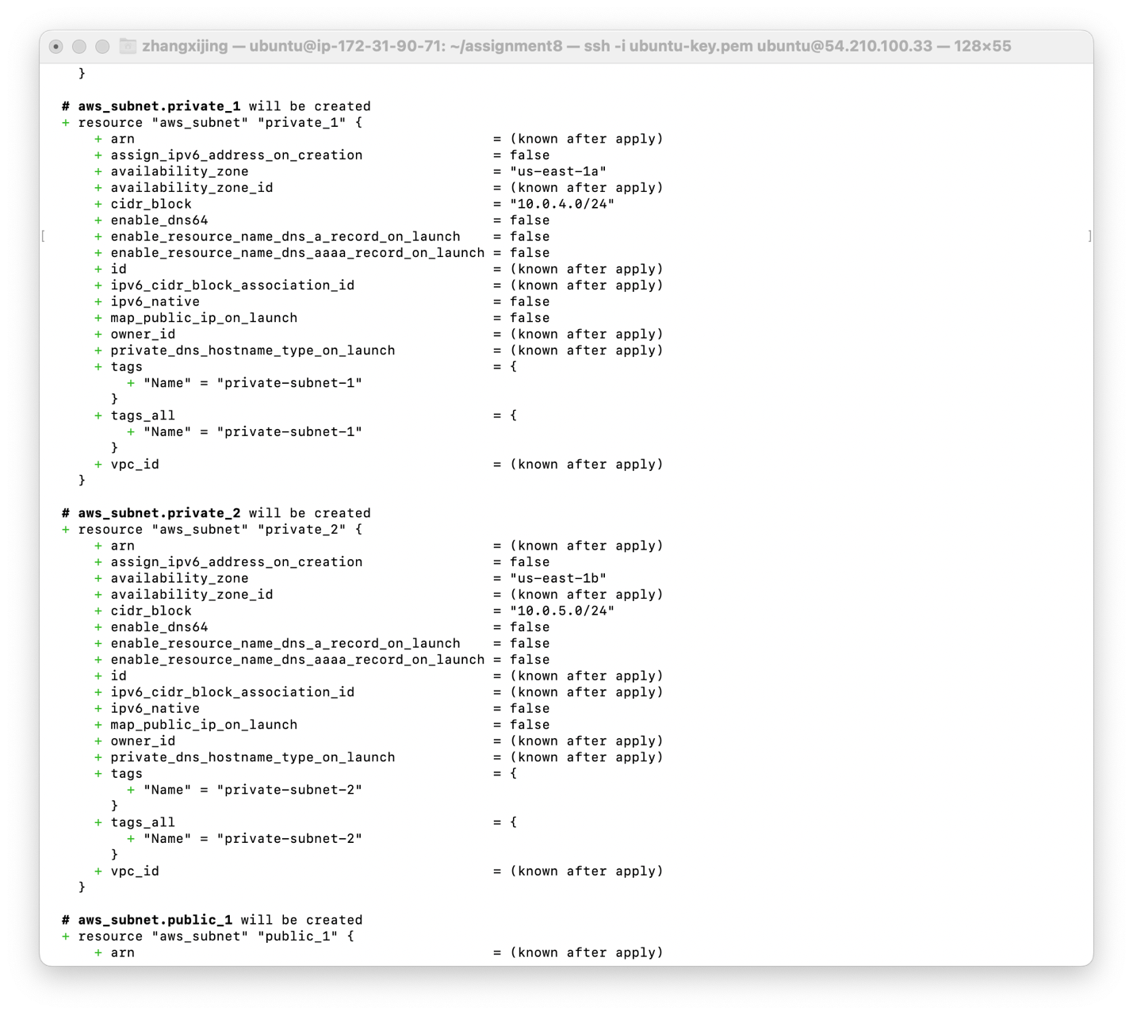

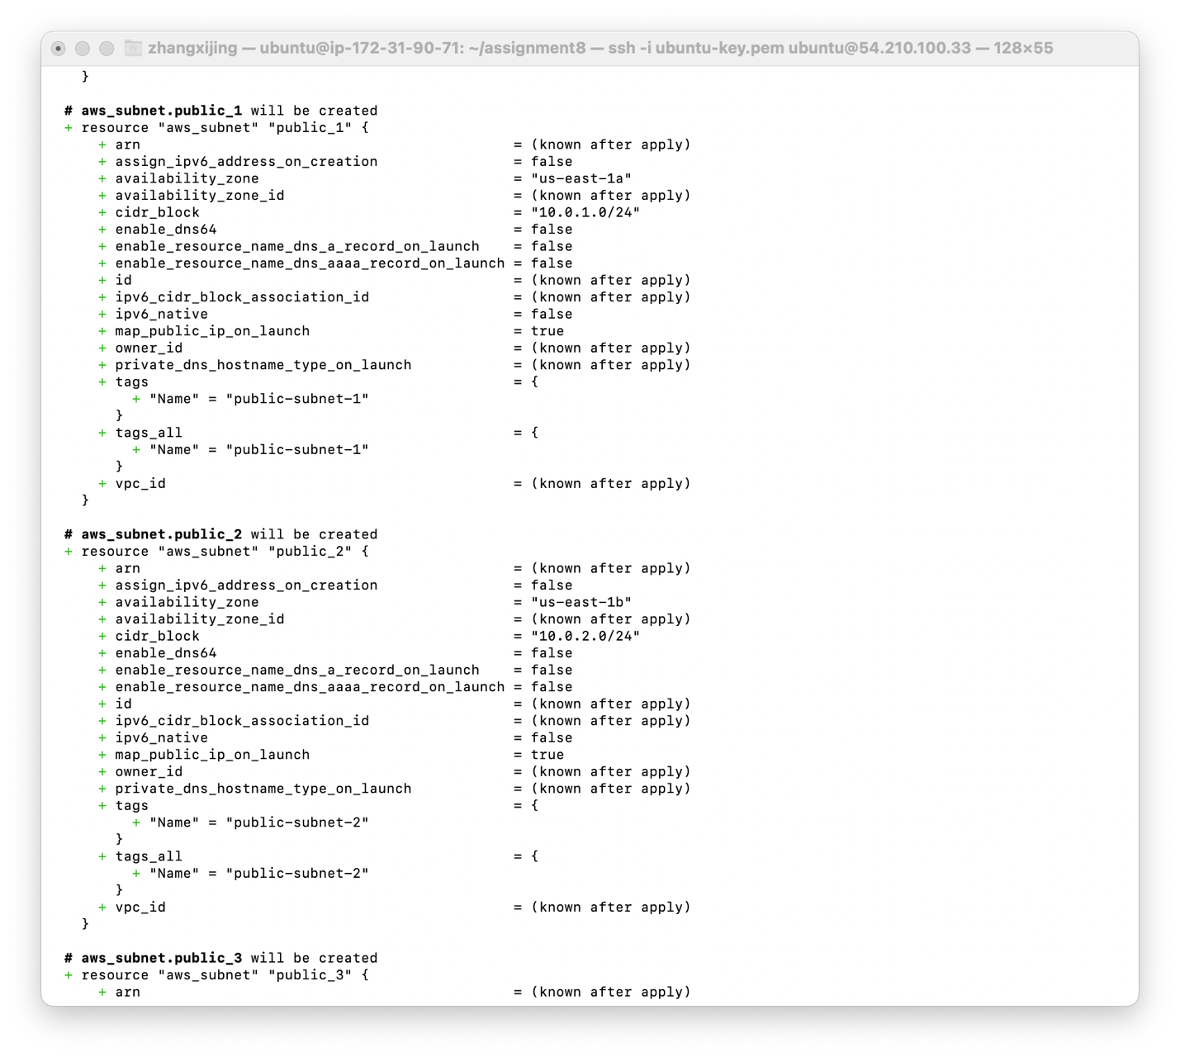

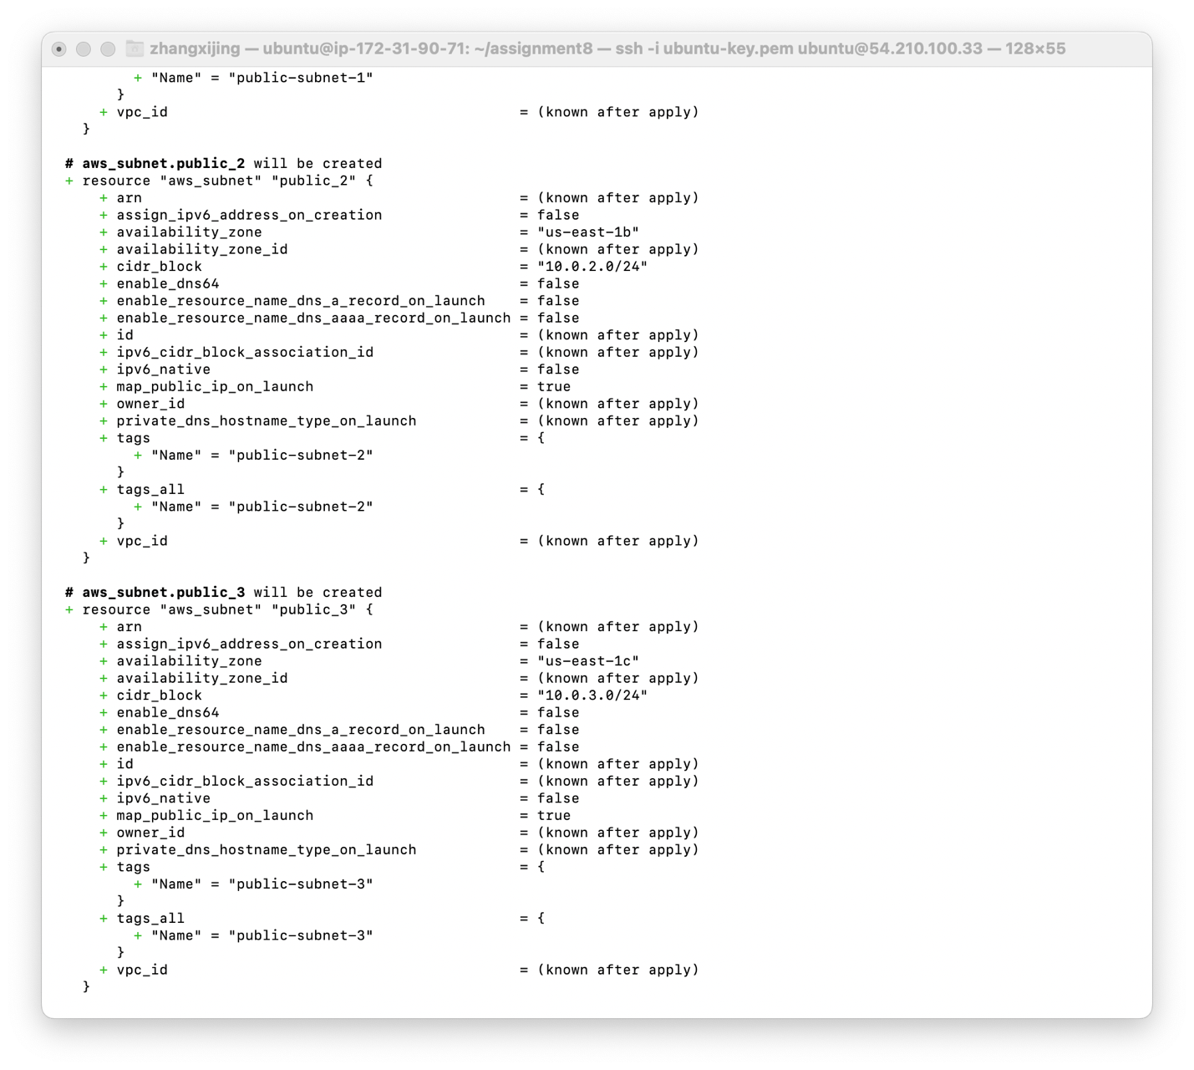

**Screenshot #3: Internet Gateway and Route Tables**

**Description:**This screenshot displays:

* The Internet Gateway (webapp-igw) attached to the VPC
* The public route table with a 0.0.0.0/0 route pointing to the IGW
* The private route table without a direct route to the internet
* The subnet associations for public and private route tables

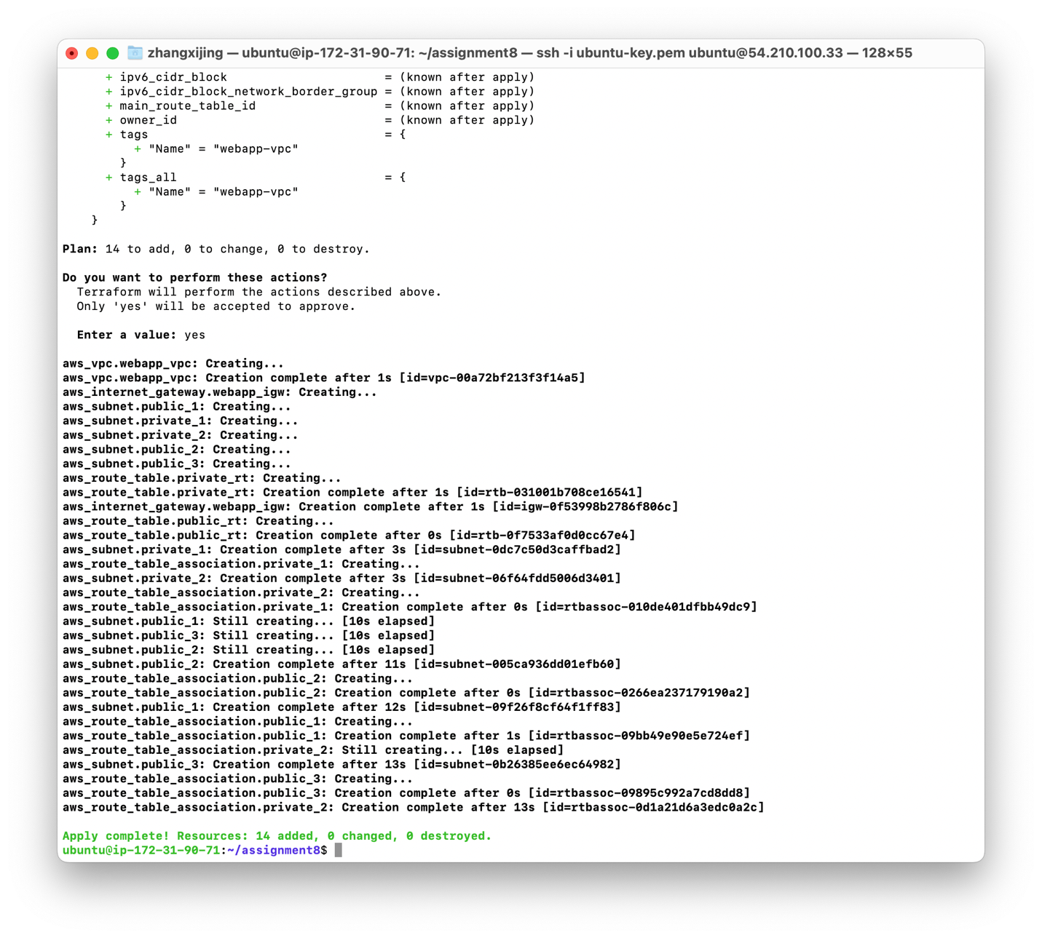

**Screenshot #4: ALB Security Group**

**Description:**Here you can see the inbound and outbound rules for the ALB’s security group:

* Inbound: Allows HTTP (port 80) from anywhere (0.0.0.0/0)
* Outbound: Allows all traffic to 0.0.0.0/0

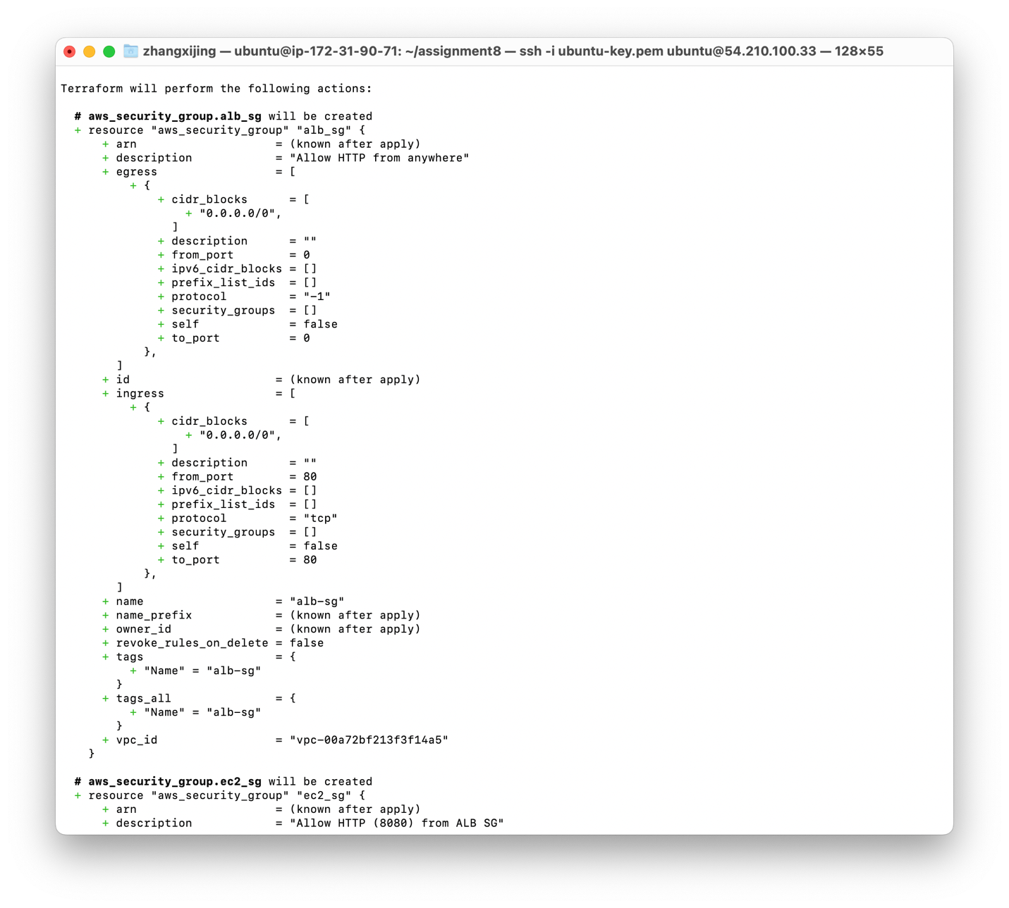

**Screenshot #5: EC2 Security Group**

**Description:**This screenshot shows:

* Inbound rule: Port 8080 allowed only from the ALB security group
* Outbound rule: All traffic allowed to 0.0.0.0/0

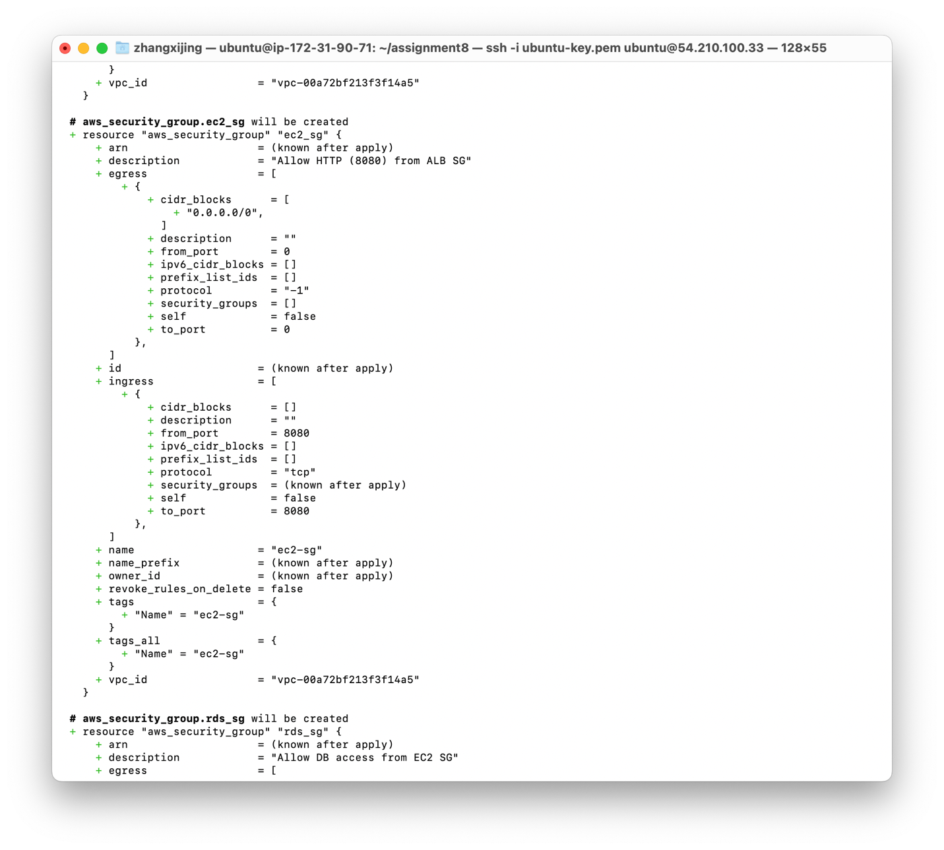

**Screenshot #6: RDS Security Group**

**Description:**  
This screenshot highlights:

* Inbound rule: Database port (5432 for PostgreSQL or 3306 for MySQL) allowed from the EC2 security group
* Outbound rule: All traffic allowed
* The association with the correct VPC

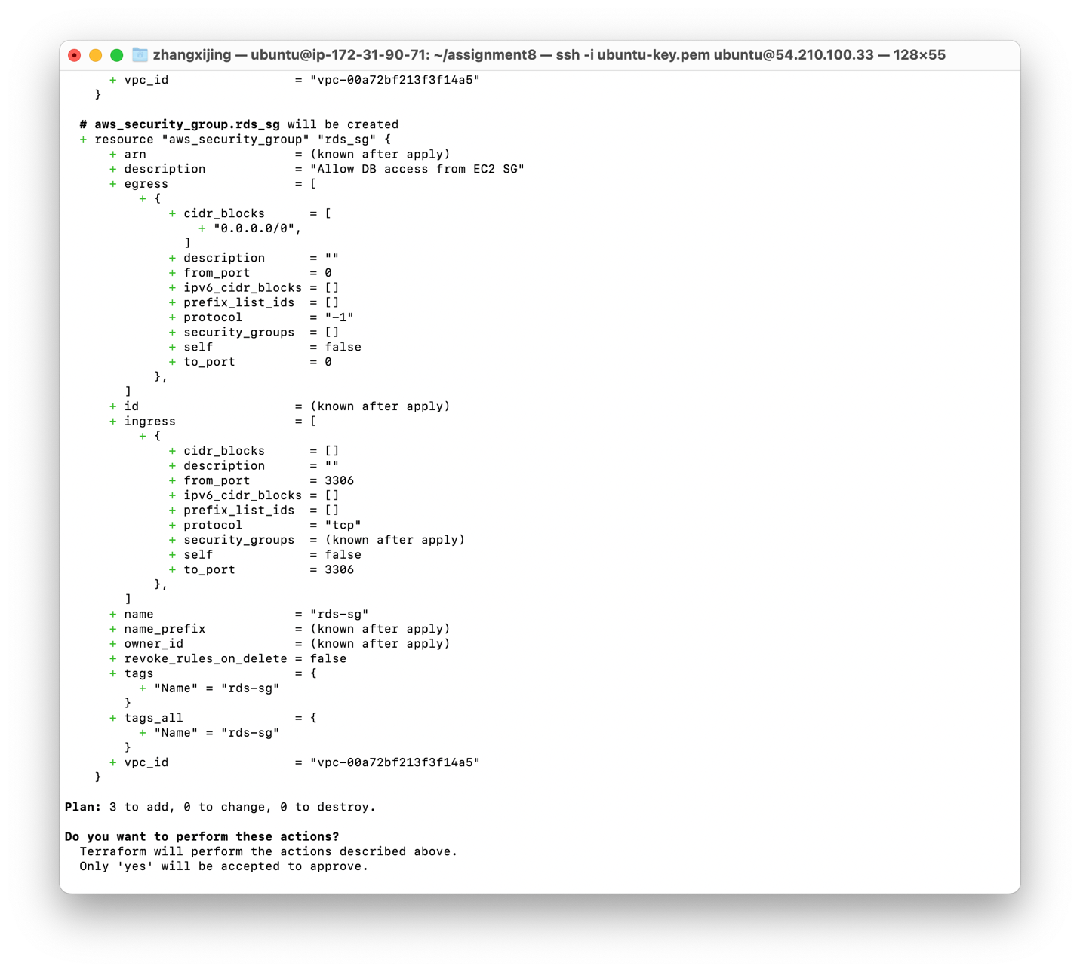

**Screenshot #7: RDS Instance Configuration**

**Description:**  
Displays the details of the RDS instance:

* Engine (MySQL)
* Instance class (e.g., db.t3.micro)
* DB name (webapp_db)
* Security group and subnet group references
* Public access disabled

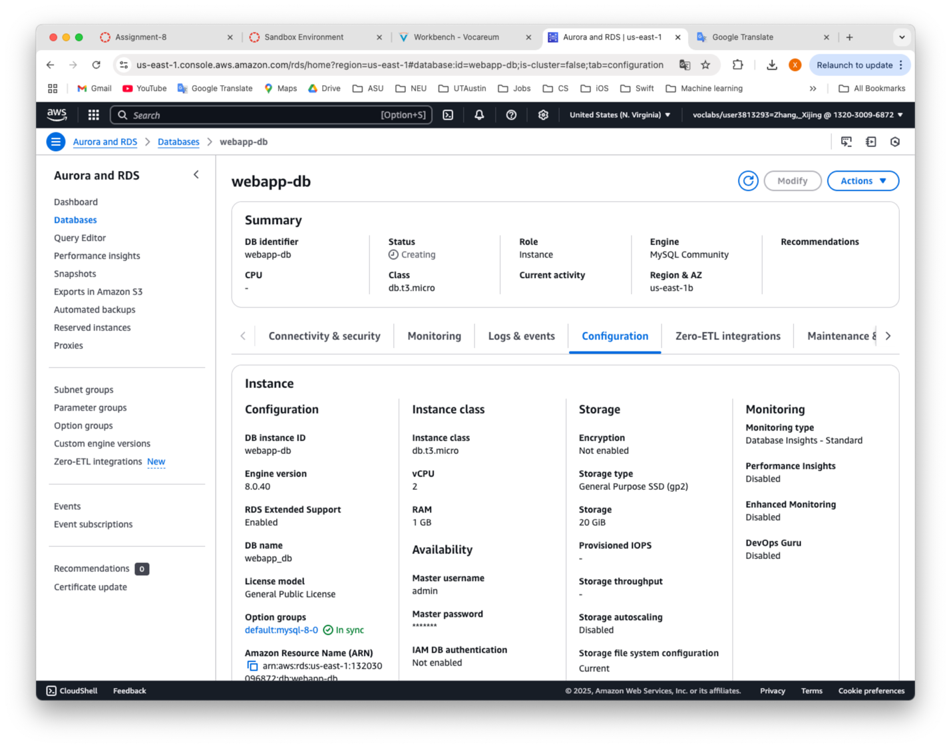

**Screenshot #8: Launch Template Configuration**

**Description:**  
Shows the Launch Template used to create the EC2 instances, including:

* AMI ID (ami-03a6c16a66bbe0a7a)
* Instance type (e.g., t3.micro)
* User data script (to create /usr/bin/csye6225/.env, set permissions, and start webapp.service)

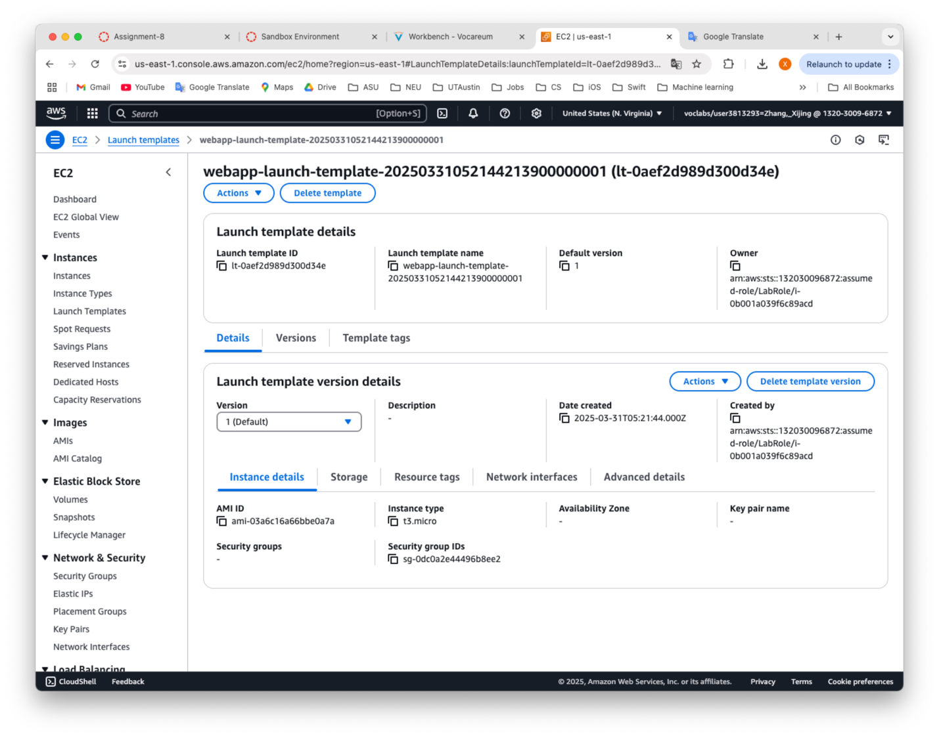

**Screenshot #9: Target Group and Health Check**

**Description:**  
Illustrates:

* Target group name (webapp-target-group)
* Protocol (HTTP) and Port (8080)
* Health check path (/healthz)
* Matcher (200 OK)

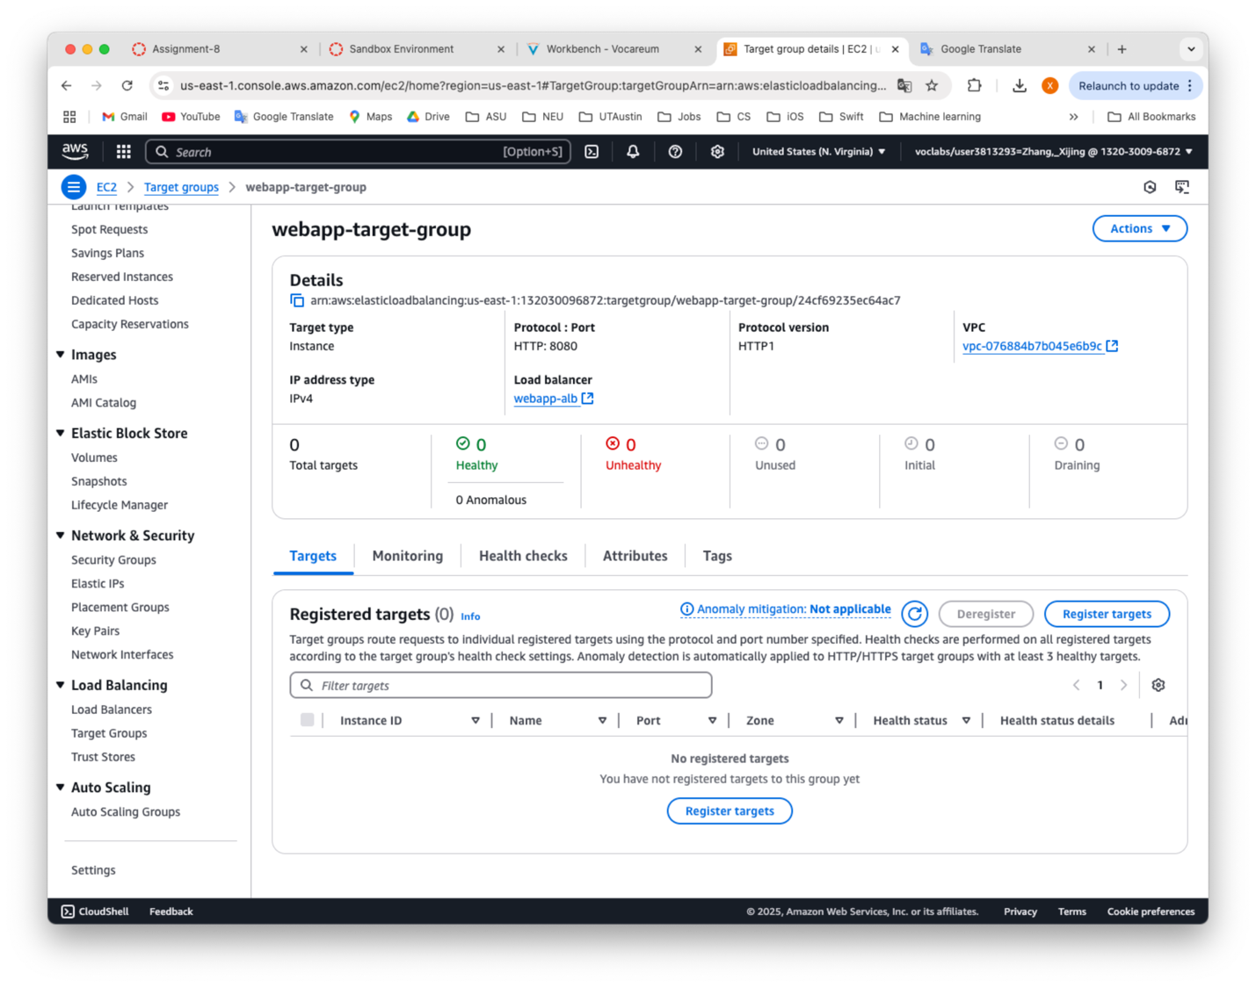

**Screenshot #10: Auto Scaling Group Settings**

**Description:**

* The ASG name (webapp-asg)
* Minimum size (1), maximum size (3), and desired capacity (1)
* VPC subnets (public subnets)
* The Launch Template association
* The Load Balancer or Target Group attachment

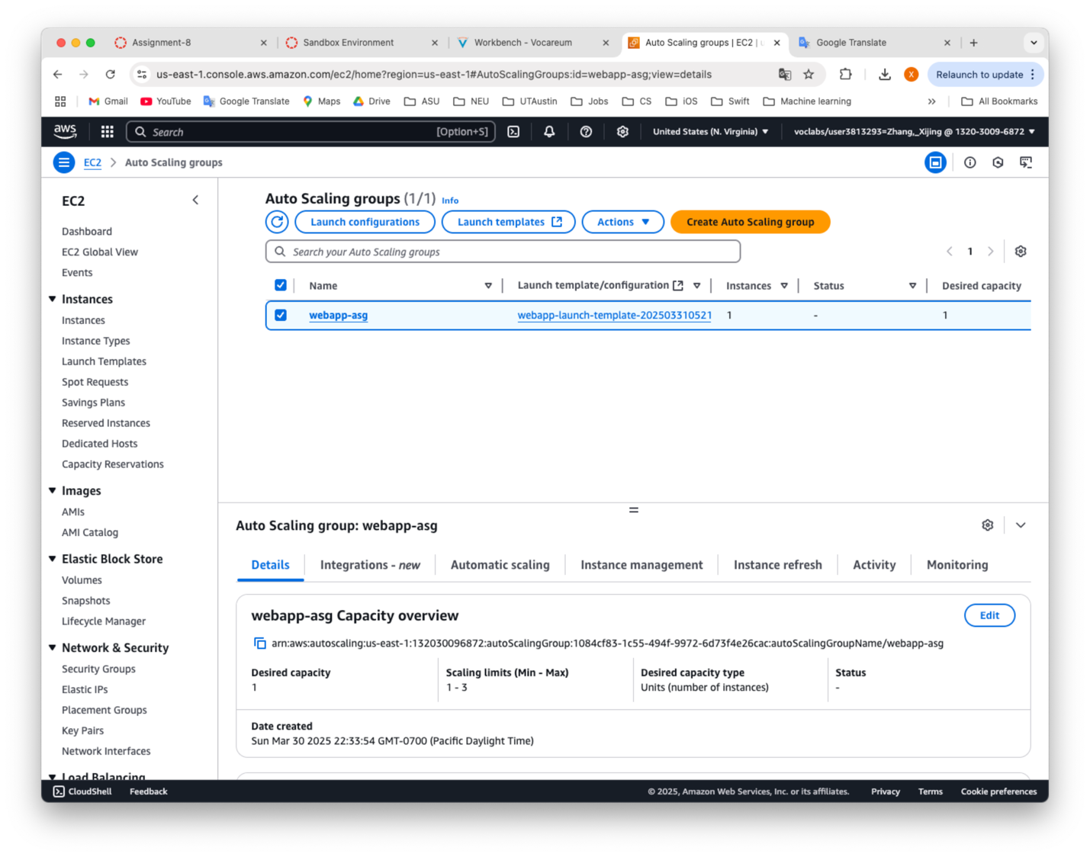

**Screenshot #11: CloudWatch Alarms for Scaling Policies**

**Description:**  
Displays the two alarms:

1. Scale Up: CPU > 70%
2. Scale Down: CPU < 30%

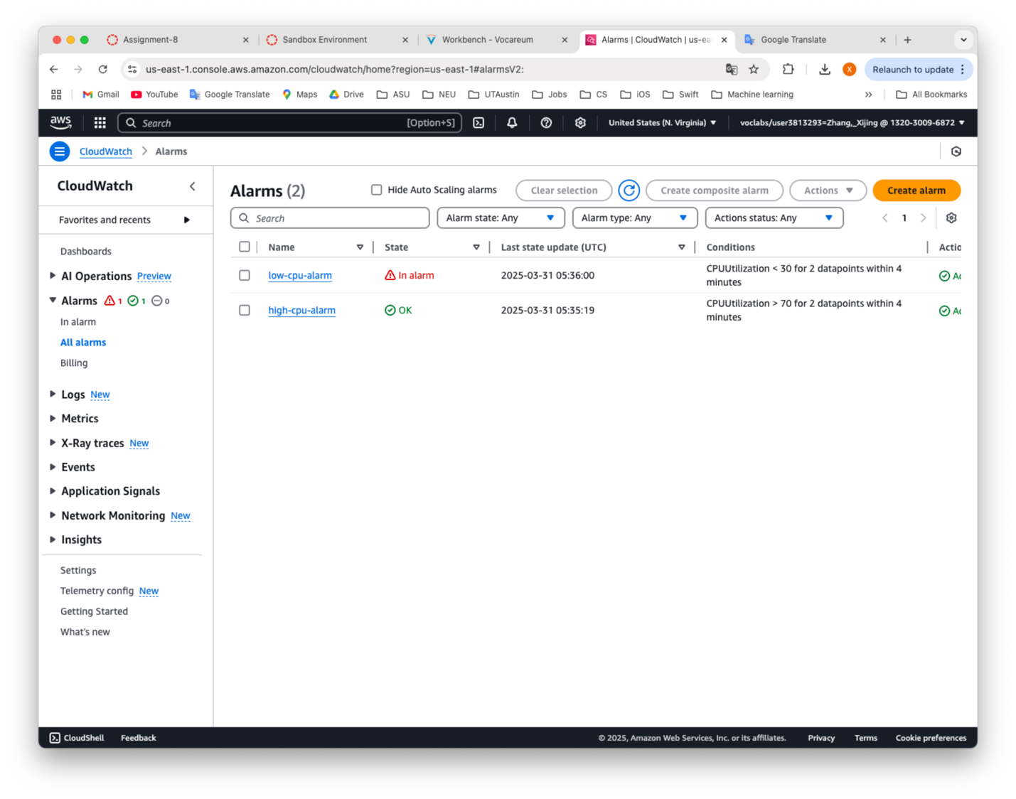

**Screenshot #12: ASG Scaling Up/Down During Load Test**

**Description:**  
Demonstrates how the ASG responds to high CPU usage by:

* Adding new instances (scale up) when the CPU crosses the threshold
* Removing instances (scale down) once the load decreases  
  Show the AWS console’s “Activity” or “Instances” view in the ASG during load testing, proving dynamic scaling.

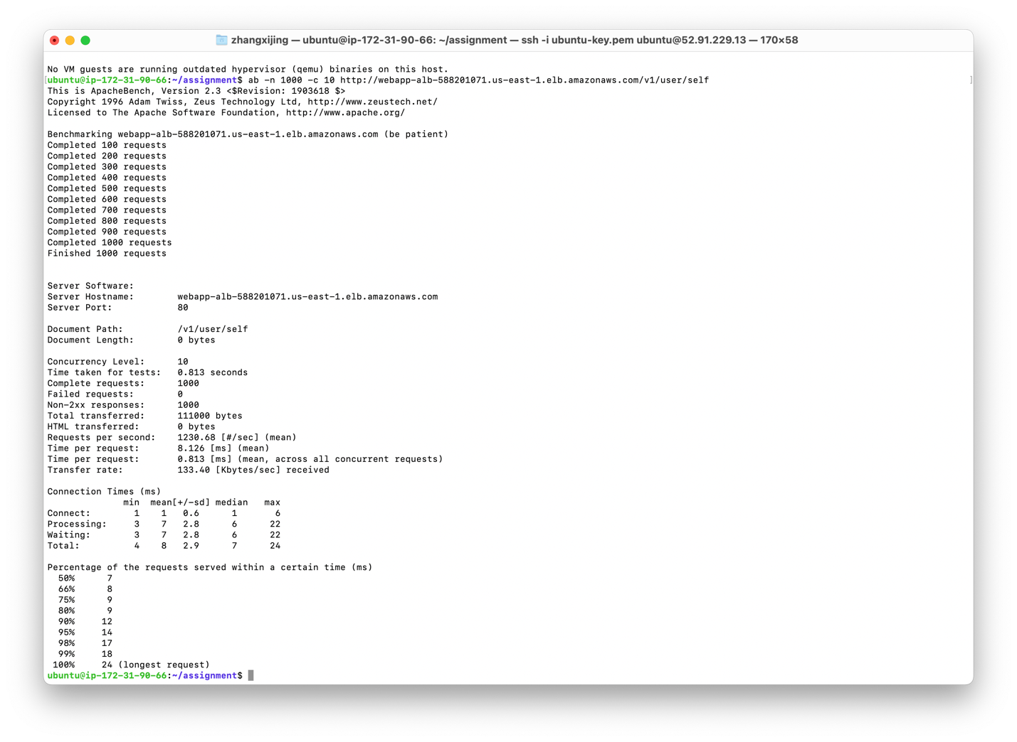

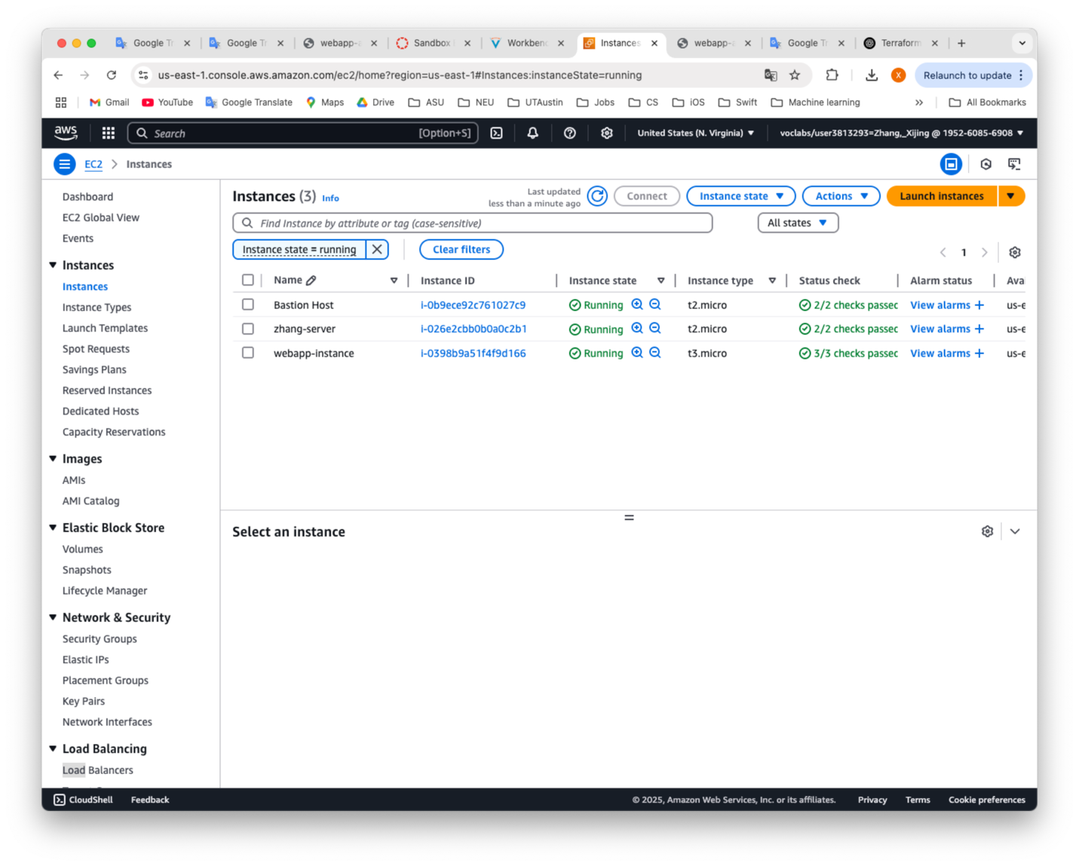

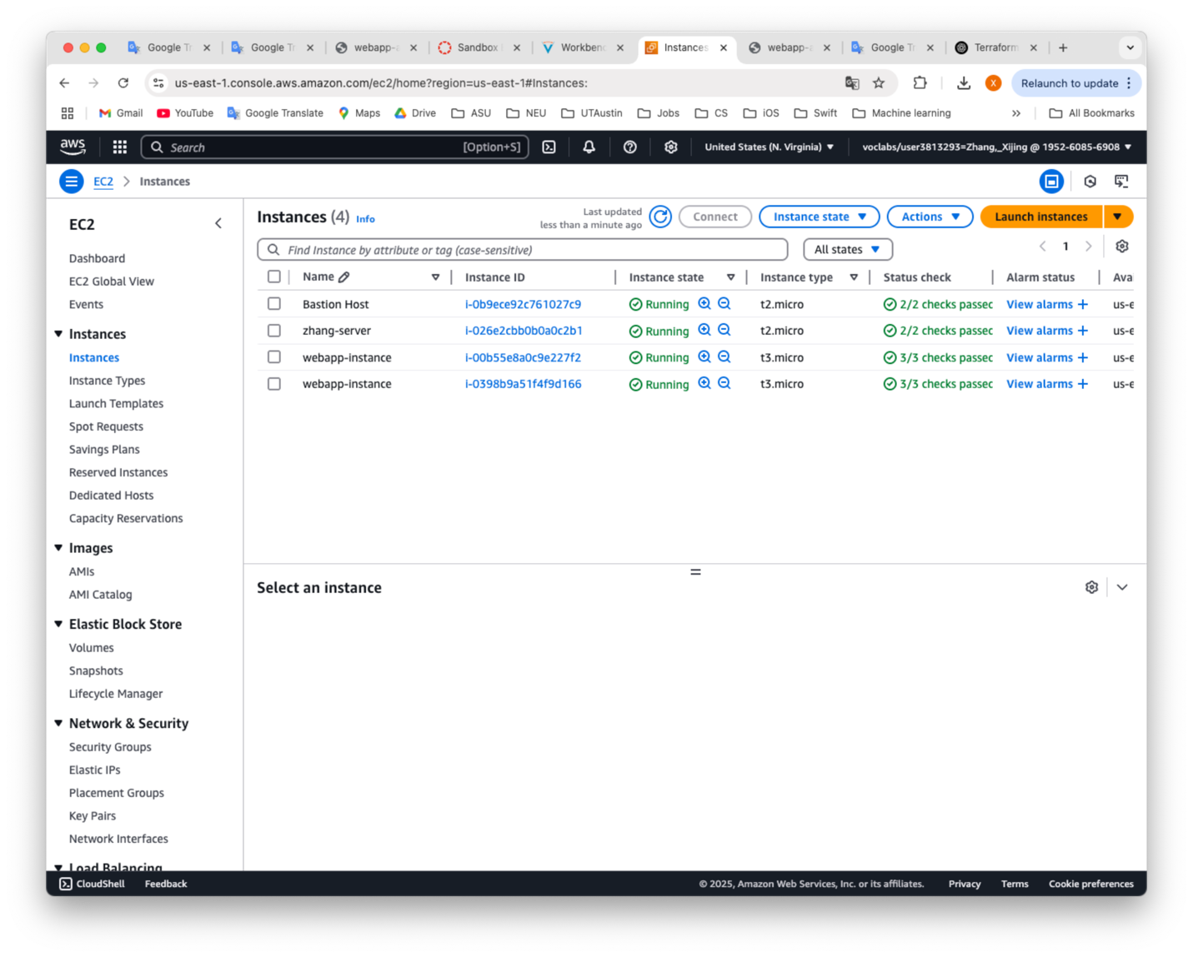

**Screenshot #13: API Requests and Responses**

**Description:**  
Includes:

1. Create User (POST /v1/user) request and response (e.g., 201 Created).
2. Get User (Self) (GET /v1/user/self with BasicAuth) request and response (e.g., 200 OK).

